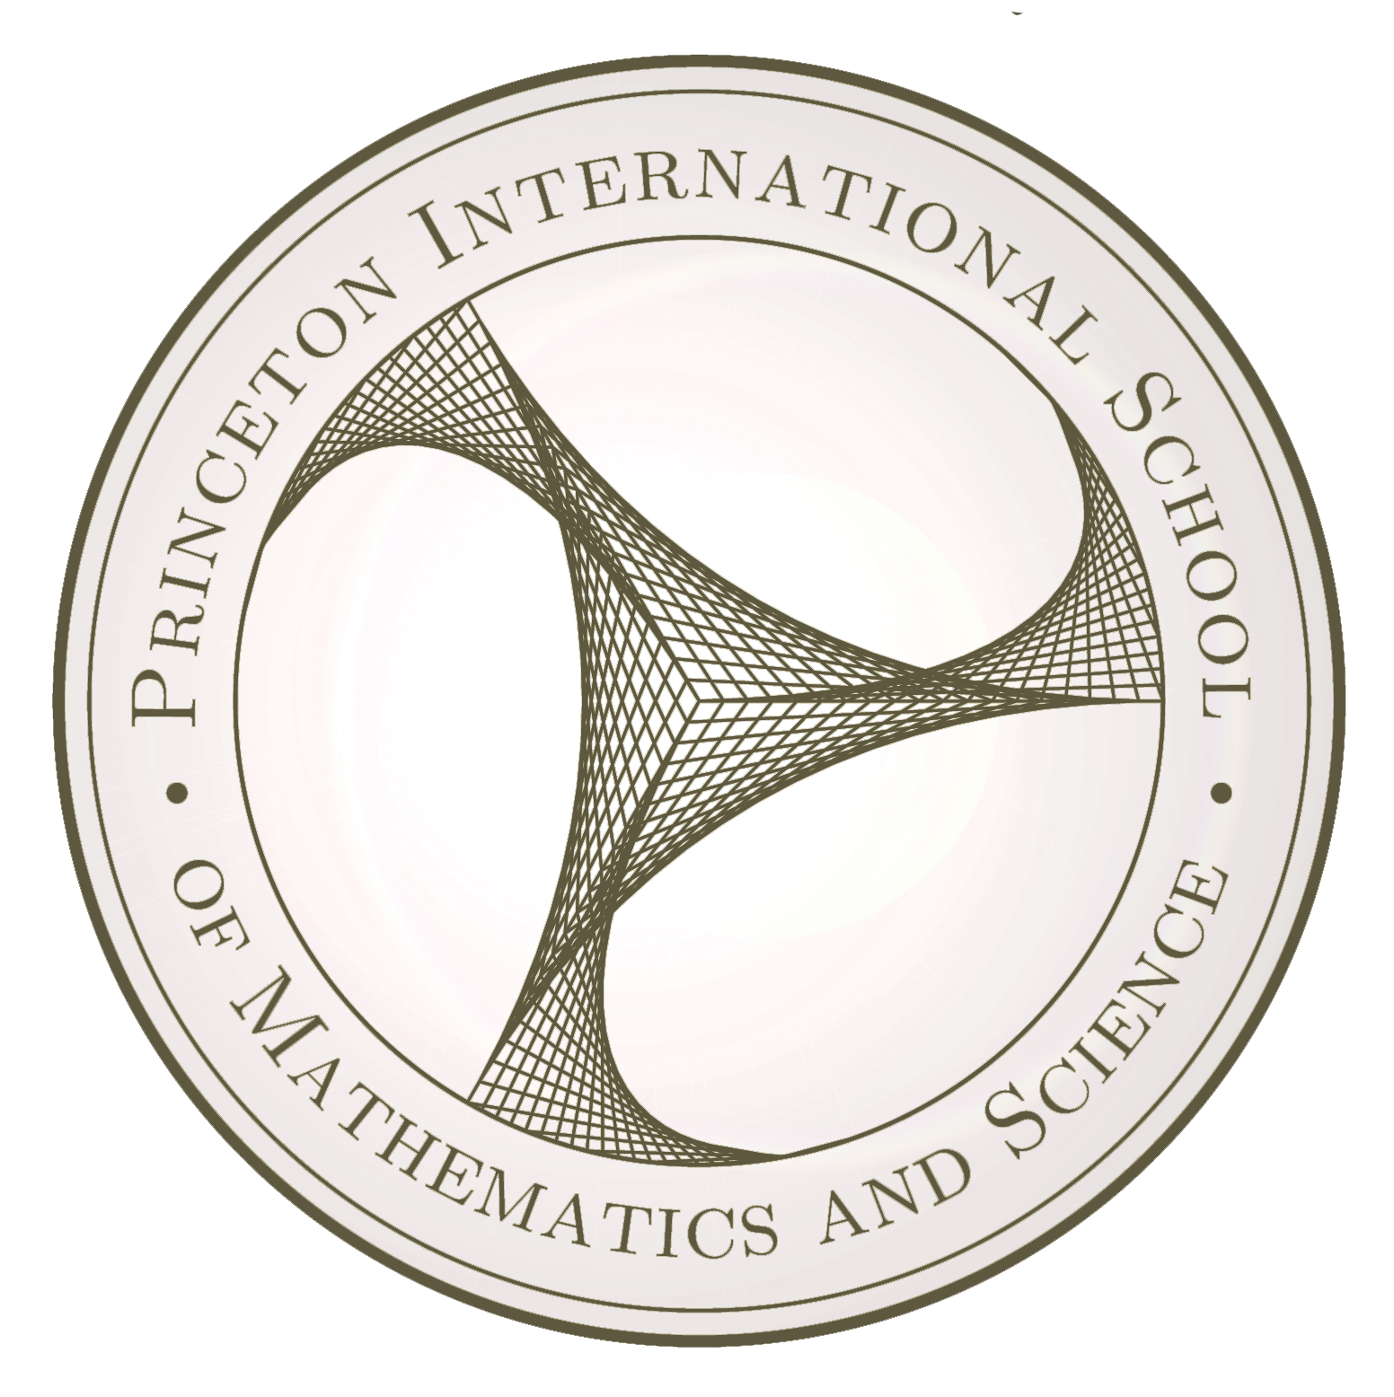

Welcome to the PRISMS Research Symposium! We hope you will enjoy learning about the projects that have occupied our students and research mentors for the past semester. These projects are works in progress, so reactions, questions, advice, and comments are highly appreciated.

Students are required to attend one panel each session. For each session, attendance will be taken and students will complete an audience reaction form. Each presenter may expect their mentor and other faculty to be ask questions related to their presentations.

For more information about these projects and other opportunities, please feel free to contact our faculty research mentors, the students themselves, or our school leadership. You may also visit our website:

www.prismsus.org

**Research Symposium**

**January 2015**

**Princeton international School of**

**Mathematics and Science**

After the final session, the Dorm Parents and Rock Band invite you for a special post-semester celebration in the main hall of Albermarle.

**3:00-3:30**

Let’s celebrate the end of term in style. You’ve worked very hard for it! Congratulations.

**19 Lambert Drive**

**Princeton, NJ 08540**

**(609) 454-5580**

**www.prismsus.org**

Session A, 8:00-8:30

1. Misha Shiltsev and Rishi Rajendran, Conference Room

2. Sophie Stockman, Room 206

3. Owen Ford, Room 210

4. Frank Huang, Room 201

Session B, 8:30-9:00

1. Anmol Anand, Room 206

2. Harry Qin, Room 210

3. Olina Liang, Room 201

4. Eric Yu, Room Conference Room

Session C: 9:00-9:30

1. Mark Liu and Daren Sia, Conference Room

2. Justin Saintil, Room 206

3. Mary Dai, Room 210

4. Gavin Li, Room 201

Session D: 9:30-10:00

1. Solomon Kim and Andy Beahan, Conference Room

2. Amy Xiong, Room 206

3. William Zhang, Room 201

4. May Ou, Room 210

Session E, 10:00-10:30

1. John Qin, Room 206

2. Echo Li, Room Conference Room

3. Lily Zhang, Room 210

4. Paulina Kulyavtsev, Room 201

Session F, 10:30-11:00

1. Harry Zhang, Andy Zhao, Vincent Lin, and Tommy Lin, Room 210

2. Leon Deng, Conference Room

3. Billy Wu, Room 206

4. Laura Tanase, Room 201

Session G, 11:00-11:30

1. Rocio Soto, Room 206

2. Clint Fu, Room 210

3. Keshav Rao, Room 201

4. Keena Feng, Conference Room

*Lunch will be Served 11:30-12:30 in the Dining Hall*

Session H, 12:30-1:00

1. Dahlia Qi, Room 201

2. Andy Zhang and Richard Xiao, Room 210

3. Tracy Han, Room 206

4. Joe Zhou, Conference Room

Session I: 1:00-1:30

1. Holly Wang, Room 210

2. Jason Lorenz, Conference Room

3. Leo Liu, Room 201

4. Aliea Nallbani, Room 206

Session J: 1:30-2:00

1. Robert Sargent, Room 201

2. Avrilla Qian, Conference Room

3. Rui Lee, Room 210

Session K, 2:00-2:30

1. Anwar Hughes-Crawford, Room 210

2. Peter Peng, Frederic Peng, and Adam Nan, Conference Room

3. Chao Liu, Room 201

4. Johan Kramer, Room 206

Session L, 2:30-3:00

1. Max Xiong, Room 201

2. Frank Zhang, Room 206

3. Harry Liu, Room 210

**Friday, 16 January 2015**

**Friday, 16 January 2015**